Youth Participation
- A short introduction. Created by the youth group in 2018.

What is youth participation?
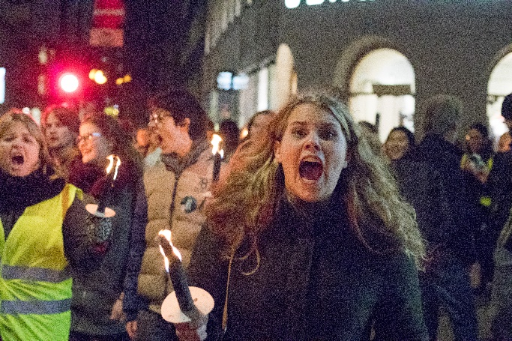
Youth participation is about youth's right to be heard, and the right of young people to actively participate in influencing and taking part in matters that directly affect them or that youth care about. Youth has democratic rights, that is, the right to engage, in accordance with the UN Children's Convention. It is a fundamental democratic principle that those affected by a decision must be included in it, is not it?

If Erna Solberg wanted to evaluate the quality of education in school today, it would be just right and reasonable that the students also had the opportunity to say how they experienced the education. They are, after all, those that go to school?
In this example, there will be a number of things that are important to keep in mind in order to achieve good youth participation. Primarily the young people themselves have to decide who will represent them. The young people who evaluate the quality must always have sufficient information. That is, they will get knowledge of what they can give input about, the deadlines they have to relate to and similar. The youth must get sufficient information. This is absolutely essential for real youth participation. Youth should not be a "trophy" for Erna to boast that youth have been represented. They must be active throughout the process and their opinions should be as important as the adults.

But who does the "youth" group really belong to?
There is no legal definition of who youth are. The UN defines youth as those between the ages of 15-24, others point to youth as a life phase and some like those who are not married or have children. As of today, Operation Day’s Work refers to young people as every person between 13-19 years old, but we are still not "locked" to this.

Why youth participation?

The National Council for Norway's Youth Organization (LNU) states: "You must recognize youth as an individual transitional phase, but at the same time understand that youth is a significant and permanent group where the demography argues for working specifically with youth." By that it is said that youth is not one lasting phase, but because of the fact that there are so many youth in the world, it is wrong to ignore this group.

Youth participation is not only correct and very important. According to the UN Children's Convention, youth have the right to say something about matters concerning them. Half of the world's population is under 30, and 28% between 10 and 24 years old. Growth in the number of young people will continue. Strengthening youth participation will strengthen the role of young people in society. By doing so, we get a better society because young people take part, make their voices heard, are included and involved.

Including youth opens up new perspectives and ideas. Youths think differently and think more openly than adults. Youth and adults in teams are therefore a perfect combination. Then adults must be willing to give up their power and be open to new inputs.
In aid, youth involvement is equally important. By investing in education and health for young people, we can help the whole population get out of poverty. Youth must not remain an unused resource, but ensure a good transition from child to adult. Then their opportunities grow for the future. Young people will be able to meet the future, to take stock of the community around them and their development, as well as being positive contributors. Youth participating in learning about democracy and development can play an important role in community development later in life.
Compared to women and children, youth are often given lower priority in the world of aid. Youth is often overlooked, although we know that youth is an important resource and that the results of the efforts are often better and more sustainable by including them. Youth must be viewed as part of the solution, not the problem.
Young people have opinions, wishes and thoughts about society around themselves and their own lives. Young people want and can make change, they just need to get the opportunity. Young people are not passive recipients, but change actors in their societies and their lives.

How to ensure youth participation?

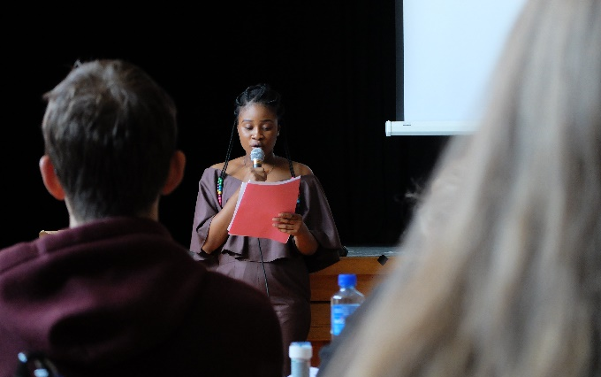
Youth participation can be so many things - that means there are many degrees. When youth lead an organization, or the planning and carrying out of an activity, we talk about youth management. Operation Day’s Work in Norway is a good example of it. In other organizations, youth may participate in the planning, implementation and evaluation of activities. Here, it is usually adults who lead the organization and are ultimately responsible for the plans being put into practice. OD supports cooperative organizations that work in this way in other countries. OD challenges cooperative organizations to be innovative in terms of youth involvement so that young people can influence their own situation to an even greater extent.

In order to bring about youth participation, mutual trust and respect between young people and adults who cooperate is crucial. In many cases, it means that adults must give up their power and influence, but it is important that youth is never endangered. Youth must receive the necessary training for what they should be responsible for. Adults can give tips and advice, but should not overcome youth with it. Room must be allowed to try and fail. Neither youth nor adults should expect youth to remain in the same place and work on the same things for a long time. There must therefore be more resources for overlap and training in organizations with youth as leaders and active participants.

Here are examples of youth participation in the OD from Norway:
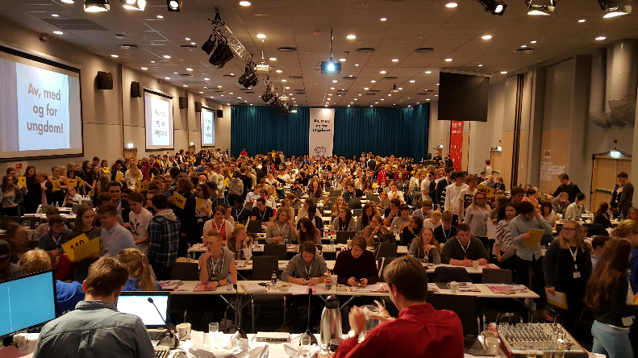
OD is youth led and has a young person who heads the organization. The board of OD is only composed of people under the age of 25. This means that young people lay the premises for what the OD should be and what we will be working with. OD’s statutes are decided and the choice of project is made at the Youth Council. Young people involved in this have good reason to be proud. Mastering and creating is engaging and makes ownership of what you are part of.

Elected youth (HK with OD leader) and the newly chosen cooperation organisations make engaging campaigns that will "hit" youth at schools in Norway. Here young people and adults work together. Since the campaign is going to "hit" youth it is crucial that it is made by youth. Young people have different thoughts and considerations other than adults. Youth often sees fewer limitations.

The organization of work on the campaign at schools is done by young student union representatives in schools and in the districts. Youth engage other youngsters and cooperate with school management and teachers. Youth organizes International Week with visualization games and lectures. Youth has an advantage over adults when it comes to engaging peers. They also learn a lot about organization and collaboration, while having fun. It contributes to personal development.
OD Assistance Councils are headed by a former OD leader and consist of 5 to 8 adult resource people with assistance experience and OD leaders for the last five actions. Here young people and adults have a golden opportunity to develop. The interaction of young people and adults enriches the discussions. Young people often think differently and can help limitations to be reduced. The Council prioritises work on youth participation and attaches great importance to it in dialogue and the exchange of experience with partners.

Here are examples of youth participation by OD supported aid projects:

OD assesses the degree of youth participation in the applications, and is particularly concerned that applicants seek to strengthen themselves in this field. OD knows that the opportunities for youth participation vary from program to program, but wish to contribute to new thinking and creativity.
Ideally, OD wishes that:
Youth participate in the development of the program from the beginning. Youth assess the situation they are from in from their own perspective. They know what youth are struggling with and what needs to be changed. This should be the starting point for planning a program that reaches youth. It is crucial that youth from the target group is represented. Ideally, those who participate should be chosen by the youngsters they should represent. The dialogue can take place through workshops, conversation groups and interviews.

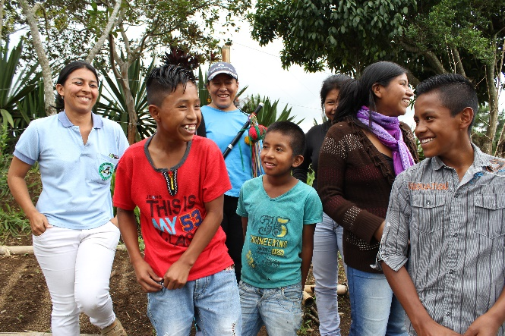
Youth is involved in the planning and implementation of the activities. To ensure that the activities benefit young people and are well adapted to real needs, young people must be involved. OD believes that youth can motivate and engage other young people. Youth are important change actors and specialists in their own situation. This creates credibility and can change attitudes in adults and other youths. Where possible, youth should lead organizations or activities.

Youth participate in evaluations along the way and in the final phase. This is because youth should be able to influence the development of the program along the way, so things can be adjusted if necessary. Youth can participate in planning and conducting evaluations. It is not enough to think of youth as interview objects in an evaluation. Young people can have their own workshops and conversation groups and attend meetings with adults. Young people who participate and contribute must be respected in line with adults. They must be prepared so that the participation is real and meaningful. They are required to receive feedback and be informed of what is happening.

Here are two examples of how youth affects their own situation.

OD 2012
In Nepal there are many customs and attitudes that are negative, primarily for girls. These concern childbirth, compulsion and isolation while menstruating. Adolescents from poor and cast-less families have traditionally few opportunities to influence their own situation.

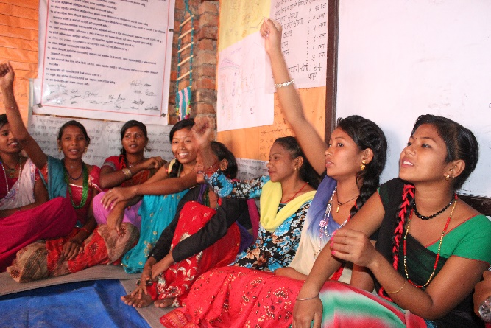
Through Samvad, which is a one-year education course, young people (who go to school, have never attended school or dropped out of school) are given education. The youth learn about issues related to health, sexuality, hygiene and social development. Teachers are young people and work more like facilitators than traditional teachers. The unique thing about Samvad is that the youngsters learn how they can organize themselves and promote the necessary changes wherever they live. For example, youth can get support to meet the leaders of the village to discuss how to ensure that all young people receive education and end childhood marriage. The Samvad youth also arrange meetings and demonstrations to get their issues heard. Themes may include hygiene, migration and child abuse. Samvad youth have mobilized entire villages and put their mark on many communities. Several villages are declared child-marriage-free.

OD2016
In Colombia there is a student organization called ANDES. The organization is always led by a young person. A new leader is elected every other year. Some may have met Daisy who contributed to OD's autumn seminar in 2016.

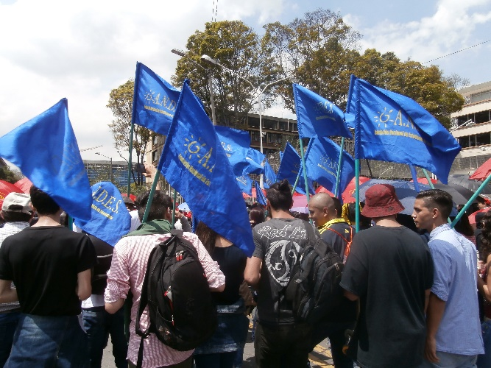
ANDES is an impressive youth organization with the ability to mobilize youth and others. It is important in the struggle for peace and justice, especially for young people and students. The organization covers the whole of Colombia and the central government of ANDES follows up through holding national meetings and leadership training and visiting the regions.
ANDES has worked a lot in recent years to inform about the right to deny the military and to prevent forced recruitment. Work in the future will also promote gender perspective and LHBT rights inside and outside the organization, and influence education policy by developing and presenting a proposal for "education for peace". ANDES will continue its work to document human rights violations.

Do you want to read more? Find the following documents:
- Operation Day’s Work - Guidelines on youth participation, May 2012
- OD's checklist for youth work (in Norwegian)
- Hart's ladder also called Robert Hart's participation ladder consisting of 8 steps, of which three do not involve participation.
- LNU's report of 1.8 million reasons. Youth, Development and Sustainability: LNU sin rapport om 1,8 millioner grunner (in Norwegian). Ungdom, Utvikling og bærekraft https://www.lnu.no/wp-content/uploads/2015/11/lnu-rapport-12-trykkfil-2-2.pdf
- “Let me raise my voice – being a young human right defender in Norway”, 2018, Press (Save the Children Youth organisation) and Redd Barna (Save the Children). Here is the link to the report in Norwegian https://press.no/wp-content/uploads/2018/11/La-meg-heve-stemmen-min-opplag-2.pdf

